Gel Permeation Chromatography (Size Exclusion Chromatography)

INTRODUCTION

There are several variations of GPC. In order of increasing power (and complexity) they are:

Preparative Gel Permeation Chromatography (GPC or SEC)
(called Gel Filtration in the biology world)

Standard Gel Permeation Chromatography (GPC or SEC)
(called Gel Filtration in the biology world)

Gel Permeation Chromatography with Universal Calibration (GPC/Universal)

GPC/Viscosity (GPC/Vis)

GPC/Low Angle Light Scattering (GPC/LALS)

GPC/Multi-Angle Light Scattering (GPC/MALS)

GPC/Low- or Multi- Angle Light Scattering with Viscosity (GPC/LALS/Vis or GPC/MALS/Vis)

There are a few other variations not listed, but these are the main ones. What all GPC experiments share is that a solution containing the polymer of interest is pumped down a column packed with a porous material. Due to diffusion, the polymers attempt to enter the pores in the packing material. But only sufficiently small polymers can enter the pores, and once they do, they are effectively trapped there until they exit again and return to the flowing solvent. In this way, the small polymers are retarded and leave the GPC column last. Various detectors are used to sense when the polymers finally emerge (or “elute”) from the column. The time it takes a polymer to elute is converted to molecular weight; exactly how depends on which variant of GPC.

The figure below shows a generic GPC setup.

Pump
Filter (ca 0.5 um)
To Waste
Optional Detector #2
e.g Light Scattering
Optional Detector #1
e.g. Viscosity
GPC Columns
Injector Loop
To Waste
To Waste
To Waste
Concentration Detector
Flow
ξ
D = 1 - 50 μm
Voids: Uniform Diameter D helps minimize voids
Pore: Size is given by the correlation length ξ

How it works: Large molecules can’t permeate the pores. They travel rapidly through the void volume. Small molecules travel partly through the porous packing materiales & go slower due to hydrodynamic shielding from the flow field (if you climb a pine tree on a windy day, it will be less windy once you’re up in the tree a bit).

IMPORTANT FEATURES OF THE GPC

Solvent: It is very important to treat the solvent correctly. It should be kept dry (using Argon, Nitrogen or Helium) and it should be degassed in some applications. The samples should be made from the same solvent--e.g., take it right from the bottle that feeds the pump. For GPC/light scattering, the solvent should be filtered before it ever hits the pump (and filtered again--see below). Common solvents for GPC are tetrahydrofuran (THF) and toluene.

Caution! THF is potentially explosive. It forms free radicals, and a free radical scavenger, butylhydroxytoluene (BHT) should always be added. When you open a new bottle of THF, check to see if it already has BHT. If not, add it at 0.025% by weight. Never distill THF (leave that to the pros on the 6th and 7th floors). Dispose of THF and all organic wastes quickly. As with any chemical waste, it should be stored underneath the hood until Waste Management can pick it up. Adding water to the THF may help. Or give it to the organic chemists; its only impurity (besides the dangerous radicals) is a trace amount of polymer. They are usually happy to have the free solvent for the simple (if you have the right equipment!) chore of distilling it safely.

Some workers add trace amounts (e.g., 0.05%) of a secondary solvent, which elutes at the very end of the run (since a second solvent will enter practically every pore). This “marker” solvent shows when the run has ended. Also, it should elute at precisely the same time from one run to the next---if the pump is working correctly. In this lab, you will use a marker solvent to evaluate the performance of the GPC columns (see below).

Pump: designed to deliver very constant, accurate flow rates. For example, our Waters pump can deliver volumes at microprocessor-controlled rates (typical: 0.99 mL/min). The pump is also designed not to produce any pressure pulses, since some detectors (esp. viscosity) can be quite sensitive to pressure pulses. To almost completely eliminate pressure pulses, use a piston pump (or syringe pump). Some pumps have a pressure gauge which will shut them down in case the tubing gets plugged. Also, some pumps allow you to connect a strip chart recorter (oscilloscope, LabView, etc.) to the pressure gauge. This can help identify deficiencies with pump performance.

Injector: The injector is a kind of fluid switch. In one position, it allows you to load the sample loop, which is a piece of tubing precut for a precise volume (typically 10 μL to 200 μL). After the loop is loaded, turning the knob on the injector to its other position will cause the output of the pump to flush through the loop, thus carrying the sample on its way toward the columns. The injector often sends a signal to the detector to indicate that the sample has been loaded. Here, we just throw the switch and push a key on the keyboard simultaneously to start gathering data.

Filter: This prevents major junk from getting to the delicate columns.

Columns: Are expensive! So treat them carefully. Never change the pumping rate by a large amount. The resultant pressure pulse can damage the delicate gel material in the columns. For example, if you are pumping at 1 mL/minute and need to shut the pump off, first set the pump to 0.7 mL/ min. Then wait about a minute and reset the pump to 0.3 mL/min and wait some more. Then finally turn the pump off. Also, be very careful about changing the solvents in a column set. If you are running THF and want to change to toluene, it might be a good idea to prepare 90%/10% THF/Toluene mixture. Run that for awhile. Then switch to 70%/30% THF/Toluene. Continue decreasing the THF content until you are running pure toluene. The manufacturers of the columns (Waters, Phenomenex, Polymer Labs, etc.) will be happy to FAX you a protocol to switch from one solvent to another for your particular column set. For example, you would wish to contact the manufacturer to get the right protocol for going from THF to dimethylformamide, DMF.

Detector(s): The detectors 1 and 2 in the figure could be viscosity or light scattering detectors. If you are using a differential refractive index (DRI) detector for the concentration, always place it last, as shown. This is because the DRI detector is very delicate; placing it last reduces the pressure on it. If one of the other detectors becomes plugged, the DRI will crack unless it's last in line. The DRI detector contains two compartments, one for the reference (pure solvent) and one for the sample. A lightbulb or light emitting diode (LED) is aimed at the two-chambered cell. The refraction of the beam as it crosses the dividing wall can be detected with incredible sensitivity (translating to about 5 x 10⁻⁸ RI units). Since the temperature dependence of the refractive index of a dilute solution is close to that of the pure solvent, temperature changes do not have a major effect. However, good DRI’s maintain the temperature very tightly anyway to decrease noise and drift. It is important to flush the DRI detector on a regular basis so that the reference refractive index closely matches the refractive index of the eluting solvent (i.e., the reference refractive index could change because it is constantly exposed to light from an LED source that is used to detect the refractive index difference, and the eluting solvent can pick up moisture or oxygen over time, thus changing its refractive index).

GENERAL PRINCIPLES.

READ THE MANUALS. This hand-out is an introduction. Serious technical stuff can be found in the manuals.

READ BOOKS. About every 2 years, a guy named Ted Provder edits books on polymer characterization, which always include lots of GPC stuff. Another important book is the one by Wallace Yau.

LET THE DAMN MACHINE RUN. Pumps are like motorboat engines: they work best when used often. The seals in a pump are very tight; if the pump is stopped for a long period of time, it may be difficult to restart it. Costly damage can result.

IF IT AIN’T BROKE, DON’T FIX IT. Corollary to the foregoing rule. If you are worried about your pump, do something simple (like using a stopwatch and graduated cylinder to test whether or not it is delivering the desired flow rate). Also, watch and listen to your pump. You may notice that the drops from its output are uneven. Anyway, don’t assume something is wrong; usually it isn’t. Although complex, GPC’s are designed for mission critical applictions in industry and they really do work most of the time.

AVOID BREATHING OR TOUCHING THE SOLVENT. THF is not good for your liver; toluene is better but not exactly therapeutic. Wear good gloves, avoid spills. Our GPC apparatus is located near a hood to minimize the danger, but some still remains. You only get one liver, and it is not reparable. If you do not know how to find MSDS data, now is a good time to find out (http://www.camd.lsu.edu/msds/Chemical-index.html)

TAKE VERY GOOD CARE OF THE SOLVENT. Keep peroxides and moisture out by flushing daily with a purge gas; you can even purge while you measure. Helium is the usual choice. For long-term storage between runs, a heavy gas such as Argon will help to keep oxygen from entering the storage reservoir, which should be a brown glass to prevent photodegradation. Peroxides can damage not only the solvent but also the expensive columns. Bad columns ooze dust and crud that can make GPC/light scattering quite impossible.

USE SOLVENT EFFICIENTLY. If a GPC instrument is not to be used for a period of time, set the pump to a low rate. BUT DO NOT TURN THE PUMP OFF! Make sure the solvent supply is adequate for the period of disuse. (A solvent use table is affixed to the wall near our instrument; use it to keep the pump from going dry!) If the instrument will not be used for a very long period of time (e.g., weeks) you can recycle the solvent (draw it from one bottle and return it to the same bottle). For best results (especially in a light scattering application) you should switch to a new bottle of solvent about one day before your measurement and just let the solvent flow to waste. This cleans out particles that may have formed due to shredding or radical decomposition of the polymer gel.

DO NOT OVERLOAD THE COLUMN. For DRI detection, use 1 mg/mL or less, and a loop size of 20 - 100 μL should suffice. Lower is better as long as the signal stays quiet. Concentrations and/or loop volumes may have to be a little higher for light scattering. Only in very special circumstances should you inject a sample at a concentration greater than about 5 mg/mL. If you cannot detect this level, consider another solvent having better optical contrast with the polymer---or consider alternative detection schemes (e.g., UV-Vis).

USE THE SOLVENT FROM THE PUMP BOTTLE. To minimize errors, especially for small polymers that may elute near the end of the run with the solvent impurities, it is best to make the solution using the same solvent that the pump is currently using.

EXPECT TO DO A LOT OF PLUMBING. You will have to change loops, insert filters, replace pulse dampeners, repair pumps, etc. Have someone show you about compression fittings, learn not to overtighten, etc.

LEARN WHERE TO BUY STUFF. Chromatography is an enormous enterprise, and all sorts of neat gadgets have been invented to make it simple and reliable. Try catalogs by Upchurch, Alltech, Optimize Technologies, Small Parts, etc. In our lab, the chromatography catalogs are located separately from the rest.

KEEP A NEAT, WELL-STOCKED WORK AREA. Good advice for all methods, not just GPC. But a dead GPC is particularly obnoxious because of the solvents it exudes and the length of time it make take to restabilize.

FILL OUT THE LOG-BOOK WITH EACH USE. Make a special note of any problems encountered.

TECHIE DETAILS & HINTS

RHEODYNE INJECTOR CONNECTIONS.
Port 1 to 4: Injector Loop
Port 2: from pump
Port 3: to column
Port 5: Inject In
Port 6 (or R): Waste

Hint: you may have to take off some connections to put others on; the back of a Rheodyne injector is a crowded place!
“THEORY” FOR REGULAR GPC

Regular GPC is not an absolute method. The system must be calibrated with polymers whose molecular weights are known by some absolute method (e.g., light scattering, osmometry, mass spectroscopy or analytical ultracentrifugation). Standard polymers can be purchased from sp² (Scientific Polymer Products) or Polysciences or elsewhere. The best polymer with which to calibrate your system is one having a similar persistence length (characteristic ratio) to the material you wish to study. For example, it would make sense to use poly(styrene) standards to calibrate a column set for poly(chlorostyrene) characterizations. It would make less sense to use polystyrene standards to calibrate an instrument for poly(stearylglutamate) samples, since the latter are very rigid. There is a hokey way around this problem (see Universal Calibration below) but the best way is to use either GPC viscosity or GPC light scattering. Note: it is tedious but completely acceptable to fractionate a homologous series of polymers and use these to calibrate an instrument for unknowns.

Anyway, for regular GPC just run your standards to obtain a figure like this (hopefully better!)

DRI
Crud at void volume due to dirty injector
Water spike

time or volume
V_{e}

Note the V_{e} for each standard you run. Make this calibration plot:

V_{e}

log M

V_{o}

Note that all the large M’s come out at nearly the same volume, V_{o}. This is because none of the very large polymers ever enter a pore. So they all elute together at the void volume, V_{o}. It is customary to plot log(M), not M. Note that the independent variable is plotted on the y axis by convention. In any case, it matters very little: you have at this point a calibration curve. Next we will see how to use it.

The calibration curve is reproduced below, and superposed on it is an experimental curve for some broad-distribution material to be analyzed.

logM

DRI

M^{A}

V_{e}
A
V_{e}^{A}
DRI^{A}

With such a curve, you are to select a representative sampling of points. For example, consider point A, indicated by the cross. Starting at V_{e}^{A} read up until you hit the M vs. V_{e} trend and then read left to get M^{A} from the left y-axis. Obtain DRI^{A} similarly from the right ordinate. Repeat for as many points as you wish! The DRI response is proportional to the concentration of polymer:

DRI ∝ c ( in g/mL)

The constant of proportionality is dn/dc, the same specific refractive index increment needed in light scattering. You cannot measure concentrations in an isorefractive solvent (i.e., one in which dn/dc = 0). However, it is not necessary to actually know dn/dc in simple GPC. One can obtain average molecular weights without it. For example:

M_{w} = 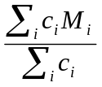 = 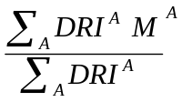

since the constant of proportionality factors out of the numerator and denominator identically. One can also obtain the number average molecular weight:

M_{n} = 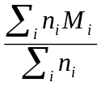 =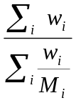= 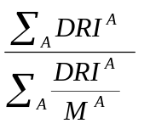=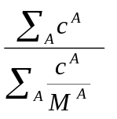

In a certain sense, computing averages such as M_{n} and M_{w} is retrogressive: the whole idea of GPC is to obtain a picture of the distribution of mass. However, statistics such as M_{n} and M_{w} are convenient and accepted statistics about the distribution. In particular, the ratio M_{w} :M_{n} is used to characterize the breadth. Without simple statistics, we wind up overlaying lots of GPC curves. And….the curves change a bit with the column set and over periods of time, as the columns degrade. The M_{n} and M_{w} values should not.

A SIMPLE GPC EXPERIMENT

Step 1. Ascertain that GPC is working OK by:

1a. Check the volume flow rate with a stopwatch and graduated cylinder. Someone will explain the Byzantine plumbing system to you and point you in the direction of the output. The rest is obvious.

1b. Measure the number of theoretical plates, N. This is done by adding a small drop of toluene to some THF and injecting it as a sample (for aqueous 0.5 μL of ethylene glycol or glycerine —e.g., 0.5% glycerine by 100 μL injected). Less than 0.05% toluene should be measurable. You will be shown how to inject samples/collect data, etc. The number of theoretical plates (i.e., the resolving power of the column set) is related to the narrowness of the signal obtained:

N = 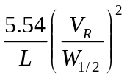

This equation gives the number of theoretical plates per meter of column, where L is the column length in meters, V_{R} is the retention volume of the injected sample, and W_{1/2} is the width of the peak, measured at half the maximum height:

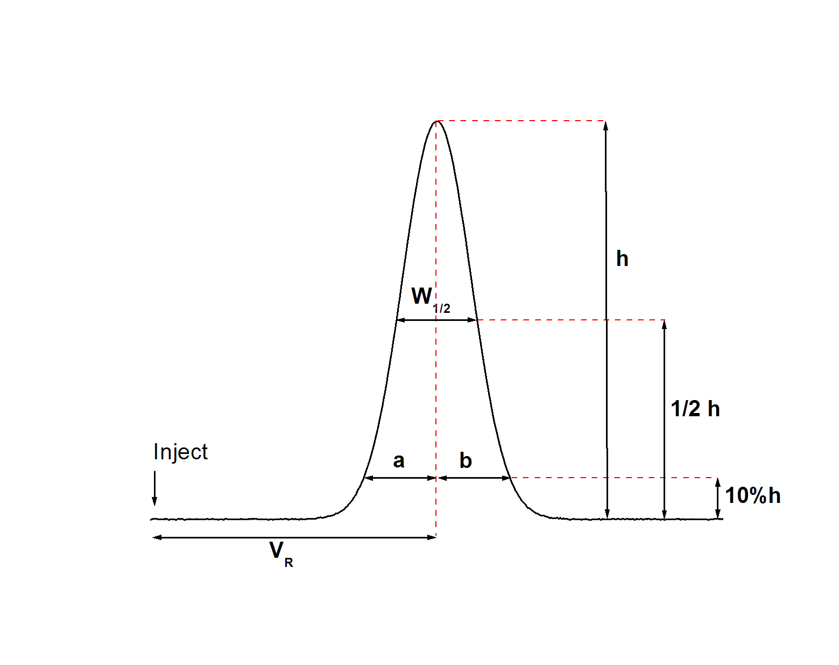

Good performance is indicated when N > 20,000 plates/meter (>10,000/foot aqueous). Somewhat lower values would be acceptable. Different formulae exist; for example, consult the Phenomenex or PL manuals, or give your friendly representative a phone call. If N < 20,000 consult the professor, who will moan about the high cost and short lifetime of GPC columns, and then instruct you to do the best you can anyway.

1c. Calculate the symmetry of the peak (from 1b); The symmetry describes the shape of the peaks .

symmetry = a/b

a and b are the peak widths at either side of the perpendicular at the peak apex measured at 10% of peak height. A value less than one indicates a "tailing" peak, in which a large percentage of the sample elutes after the apex. A value greater than one indicates a "leading" peak. The figure below shows the results for a good column vs. a bad column.

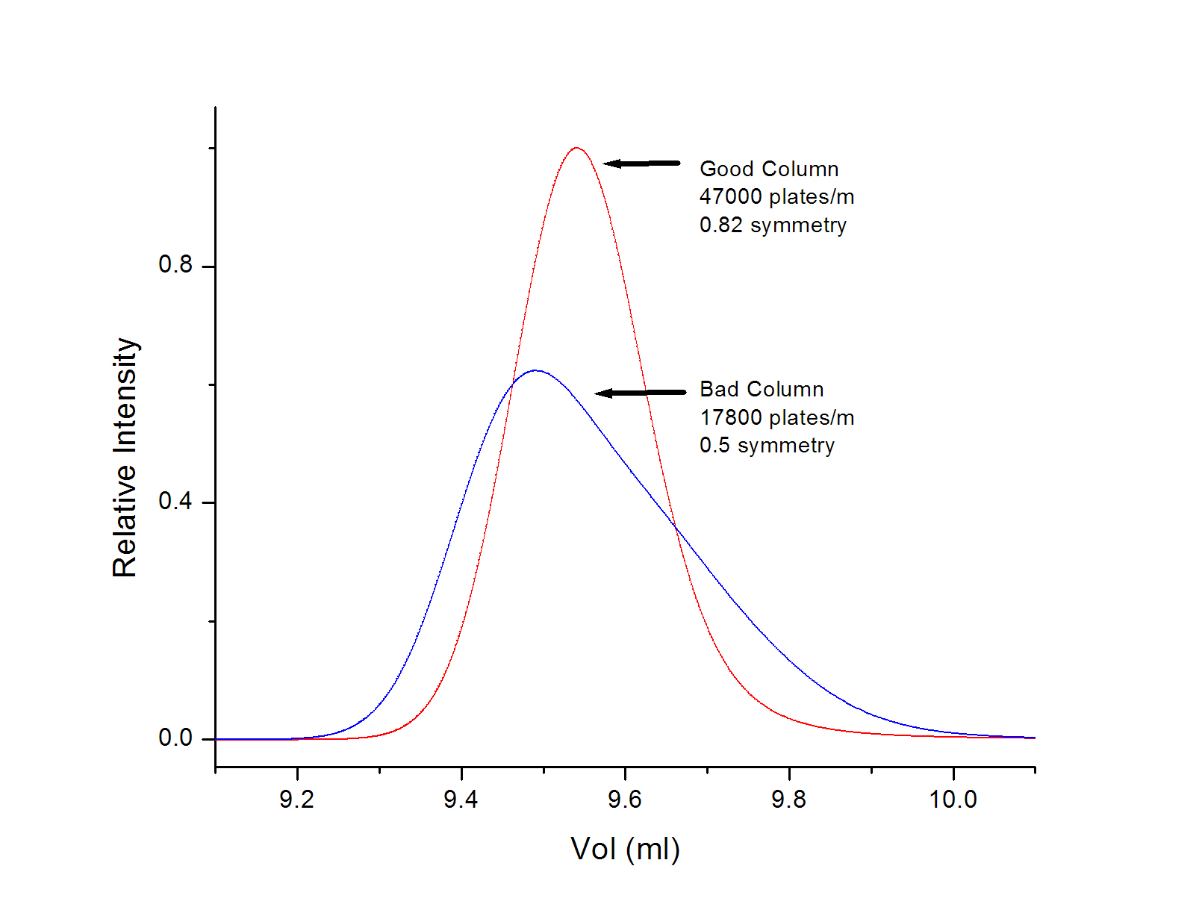

1d. Zero the RI detector.
- On the new, digital Waters 410 you press blue-button & purge. The display reads "pge". The solvent is now flowing through the reference side of the DRI detector. Let this go on for as long as you wish; it's a good idea to leave the system in purge mode overnight before the next day's work. After a suitable purge, press blue-button & purge again. The system returns to normal mode. For us this is usually Sensitivity 32 and Scale Factor 20. Check that this is so. Then push blue-button/autozero. The system automatically finds zero.
- On the old Waters 401 detector, you can use a digital voltmeter to perform the zero, or set the ASTRA data acquisition software (or even a chart recorder!) into "continuous measure" mode. Someone will help you if you don't know how. Switch the front panel control to "Zero Test". Adjust the electronic baseline control to give a near-zero voltage reading; the baseline knob points to about 12 o'clock normallly. Switch the polarity control from + to - to ensure that you are really at zero (a null signal doesn't change with polarity). Then switch the attenuation knob to 128x. This is the least sensitive reading. Adjust the optical zero until you see zero. Test with the polarity switch again if you like. Then try 64x and all the others. Finally, you will have zeroed the detector. This instrument is much less sensitive than the Waters 410 and is frequently operated with no attenuation.
- On the Hitachi L-7490 you press the purge key. The display shows differential refractive index in a unit of 10⁻⁶ RIU. You can also read the signal in volts on the DAWN display (aux 1). A few minutes is enough for the purge. Press the purge key again (purge light goes off). After this press Zero key. Make sure that the range is set at 32.

Step 2.

- Obtain the calibration curve using standard polystyrenes . You should do this with friends and/or lab partners. A good idea is to make “cocktails” – mixtures that contain several standards. That way, you don’t have to make so many injections. But don’t make the polymers too close. For example, you might run these three polymers together: M=20,000, M=400,000 and M=1,700,000.
2) Find a sample of polystyrene somewhere in the real world. I suggest Burger King, MacDonald’s, a Revell model airplane, model cement with which to build that plane, etc. Measure M_{w} and M_{n} for this sample using simple GPC. Choose carefully, and choose a white sample; you may use the same sample in some other future experiments.

As described above, make just a 1 mg/mL solution (or less). To prevent damage to the GPC instrument, we will prefilter all solutions using 0.1 or 0.2 μm filters. Take care to select filters that are compatible with your solvent! (A compatibility guide is in the filter drawer). You will be instructed how to run the instrument to avoid damaging the injector or columns. Make a printout of your file and determine the points graphically. Compute M_{n} , M_{w} and M_{z} and all the appropriate ratios. In your report, speculate on the synthetic route used to make your particular sample of polystyrene (consult a textbook like Rudin).

Step 3. Embellishments

It is fully my intent that you should analyze your data graphically, maybe using a calculator I know of no better substitute pedagogically. However, this is NOT how GPC is actually done anymore. For example, you can fit an equation through the V_{e} vs. log₁₀M function (we plotted it log M vs V_{e} -- little matter). The software we use (ASTRA, most probably) to generate your data files has, as an option, a conversion to make ASCII (i.e., text) files. You could feed these into a spreadsheet and convert every point on your trace to c and M. For fun, write a little Visual Basic program to handle the data!

REPORTING REQUIREMENTS (IF YOU ARE TAKING A LAB COURSE)

- Draw a picture of our actual GPC setup (it probably includes a Wyatt DAWN light scattering detector, even though we don't use it in this particular experiment). Include all the little plumbing parts, from solvent bottle to waste return.
- Draw a picture of the electrical connections, indicating the function of everything.
- Show a trace with 0.05% toluene/THF (about 0.05%--doesn't matter too much) and compute the number of theoretical plates. Why is this number (probably) so low?
- Show a trace with your "cocktail" of 2-4 PS samples, ideally well-resolved.
- Show a calibration plot, combining your cocktail data and that of other groups.
- Use your calibration plot to determine the peak molecular weight, M_{p}, of an unknown (tell me what the unknown is!). Do this manually.
- Now fit a curve through the calibration data. Everyone in your team should do this separately so you can see how sensitive the answers are to the fitting method chosen. It can be a line, polynomial--whatever you think actually goes through your data points.
- Show a plot with the calibration points and the fitted line/curve/whatever.
- Use the calibration equation to determine M_{p}, M_{n}, M_{w}, M_{z}, M_{z+1}. This requires either that you manually evaluate many points or do it in Excel, Origin, or a higher-level program.
APPENDIX

Explanation of the different volumes on GPC columns

Void Volume ( V_{o} ): Also called interstitial volume or exclusion volume; It is the volume of solvent (mobile phase) that is located between the column packing particles.

Pore Volume ( V_{i} ): Pore volume of all particles.

Mobile Phase Volume (V_{t} ): V_{t} = V_{o} + V_{i}

Gel Volume ( V_{g} ): Volume occupied by the solid support (gel).

Column volume ( V_{c} ): V_{c} = V_{o} + V_{i} + V_{g}

Retention Volume (Elution volume) (V_{R}): V_{R} = V_{o} + (K_{sec} x V_{i})

K_{sec} = distribution coefficient (ratio of average concentration of solute in the pore volume to concentration of solute in the interstitial volume:

K_{sec} = <c>_{i} /<c>_{o}

This is true if only size interactions are involved ( no enthalpic interaction).

V_{i} is the most critical parameter.

The extrapolated molecular weight values that occur at V_{o} and V_{t} are known as the exclusion molecular weight (W_{o}), and the total permeation molecular weight (M_{t}). This two values define the molecular weight range for a column, and depend mainly on V_{i}.

Tipically V_{o} ~ 35% of V_{c}

V_{g} ~ 20-30% of V_{c}

People sometimes call V_{t} the void volume; this comes from HPLC where V_{i} is very small.

Test V_{o} with a very large solute that can not penetrate the pores (sometimes difficult).

Test V_{t} with a very small solute, or non-degassed solvent

