Densitometry--Determination of the Partial Specific Volume

Introduction

The partial specific volume is useful for interconverting weight fractions (wt/wt) , concentration (wt/vol), and volume fraction (vol/vol). It also illustrates the whole concept of partial molar quantities, including the method of intercepts. After reviewing the theory, some features of the Paar 58 Densitometer are discussed. An experimental procedure to learn about using the densitometer is suggested at the end.

Background

A more detailed theory appears in the Chem 4011 notes, also available on the web. (Currently, http://russo.chem.lsu.edu/msweb)

Basic Symbols:

N_{a} = Avogadro's number
N = number of some chemical species
n = number of some chemical species, in moles (n = N/N_{a})
g = mass in grams
V = volume

Concentrations:

c = concentration as grams of solute/mL of solution
w = weight fraction mass of some component/total mass
φ = volume fraction, volume of some component/total volume
x = mole fraction
[…] = molarity, moles of solute/liter of solution
m = molality, moles of solute/kilogram of solvent

Subscripts:

subscript 1 = solvent
subscript 2 = solute

Thus, c = c₂ = 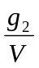

Partial specific and partial molar volumes:

One needs to know how much a solution volume would change upon adding a gram (mole) of a given component, holding the amounts of other materials constant. For the solute component, this is mathematically expressed by:

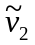 = 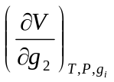= partial specific volume.
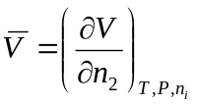= partial molar volume.

The partial derivatives are taken at constant pressure and temperature. The amounts of all the other components present in the solution are also held constant. Both quantities are really functions of the composition. The imaginary experiment suggested by the equations is to add one mole of solute to a solution that is so large that another mole of solute does not appreciably change its composition. We imagine adding a mole of solute to an ocean of solution. For example, the partial molar volume of NaCl at x_{NaCl} = 0.25 could be determined by adding one mole of NaCl to a very large solution already at x_{NaCl} = 0.25. The solution should be so large that another mole of NaCl doesn't change the composition much. In practice, this imaginary experiment is replaced by the method of intercepts.

The Method of Intercepts

We normally do not know polymer molecular weights very accurately. Therefore, is more commonly measured than 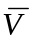. The method of intercepts for is discussed formally in the MS-II notes, and also in any Physical Chemistry text. Here we proceed for . The figure below shows the inverse of the solution density (i.e., V/(g₁+g₂)) plotted against weight fraction of solute (i.e., g₂/(g₁+g₂)). Eight separate measurements have been made. A smooth curve has been drawn through the points. A tangent to this smooth curve is drawn at w₂ = 0.38 (chosen arbitrarily).
0
1
w₂
ρ⁻¹/mL-g⁻¹
w₂ = 0.38
B
A

C
D

The intercept A is: 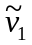 (at w₂ = 0.38). It is appreciably different from the inverse of the pure solvent density, located at point C.

The intercept B is (at w₂ = 0.38). It is appreciably different from the inverse of the pure solute density, located at point D.

Had we elected to draw the tangent at some other value of w₂, we would obtain completely different and . THESE QUANTITIES ARE FUNCTIONS OF CONCENTRATION. Over limited ranges of concentration, the inverse density curve may be fairly linear. Then one can treat and approximately as constants. This approximation has to be stated in any publication or report.

The figure suggests how to measure and .

- Prepare a series of solutions (spanning the interesting concentration range) by weight.
- Measure the density of each.
- Construct the plot ρ⁻¹ vs. w₂.
- Draw a smooth curve through the points graphically.
- Obtain tangent & intercepts graphically.

Steps 4 & 5 can be done in computer also. In this case, we fit a curve, probably a polynomial, to the data:

ρ⁻¹ = K_{o} + K₁w₂ + K₂w₂² + K₃w₂³ + …. (1)

The tangent to this curve has the slope:

m(w₂) = 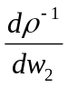 = K₁ + 2K₂w₂ + 3K₃w₂² + … (2)

The tangent line has the usual form y = mx + b:

y = m(w₂)⋅w₂ + b (3)

The intercept, b, is clearly . To find its value at a particular w₂, we seek the intersection of Eq. 3 and Eq. 1.

K_{o} + K₁w₂ + K₂w₂² + K₃w₂³ + …. = m(w₂)⋅w₂ + b

or…. K_{o} + K₁w₂ + K₂w₂² + K₃w₂³ + …. = (K₁ + 2K₂w₂ + 3K₃w₂² + … )w₂ + b

or…. b ≡ = K_{o} - K₂w₂² - 2K₃w₂³ - … (4)

Clearly, is a function of w₂.

To get , which is the right intercept of our line y = mx + b, we calculate the value of
y = m⋅1 + b using Eq. 2 for m at our chosen w₂ and Eq. 4 for b, again at our chosen w₂. In other words, = m(w₂) + b(w₂). See if you agree that:

= K_{o} + K₁ + w₂(2K₂) + w₂²(3K₃-K₂) + w₂³(-2K₃) + …

Measuring Density

Now we know what to do, but not how to measure density. One may imagine that rather small density changes might be involved. Not to worry--our Paar DMA 58 is exquisitely sensitive. The user is advised to read the manual, a copy of which is kept next to the instrument. In brief, the DMA 58 works by making it easy to fill a U-shaped tube with a constant volume of fluid (you must take great care to keep it constant by not letting stuff adhere to the cell walls). This volume is then made to oscillate at a high frequency (not using a hammer, as shown below!). Its mass is determined very precisely from the period of the oscillation.

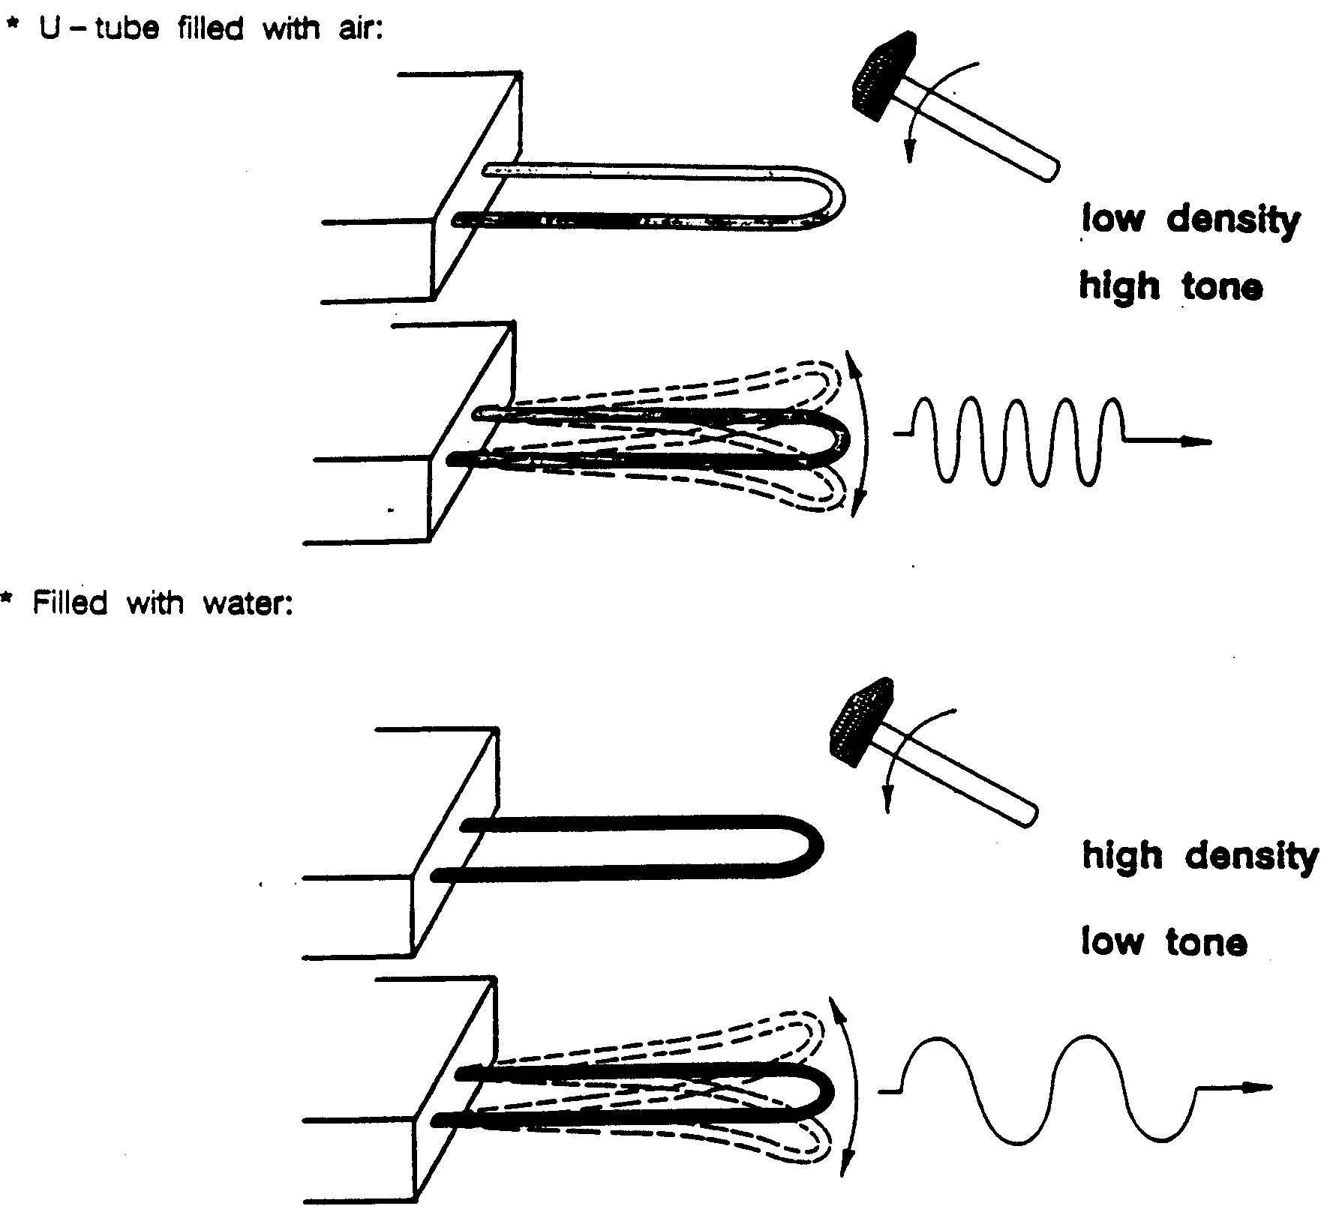

How good is the DMA 58? Damn good! From its manual: "…an accuracy of ±0.00002 g/cm³ within a measuring range from 0.5 to 1.5 g/cm³…" under typical calibration conditions.
Calibration? Yes, the beast has to be calibrated…and rather often. Like daily. Fortunately, it's easy and fast. Good practice requires one to monitor the changes in calibration, which Paar chooses to call dev B. A plot of dev B vs. the number of calibrations appears near the DMA 58. If dev B suddenly changes, it probably means the previous user screwed up his/her calibration and/or left the machine dirty. Small amounts of crud on the U-shaped tube have to be cleaned off.

IF YOUR dev B EXCEEDS ABOUT 0.0005 YOU SHOULD SEE PROFESSOR RUSSO, LICATA IMMEDIATELY. DO NOT ATTEMPT TO CLEAN THE MACHINE YOURSELF. THE ONLY THING WE WANT YOU INJECTING INTO THE MACHINE IS YOUR SAMPLE IN SIMPLE, NON-AGGRESSIVE SOLVENTS, PURE SOLVENT ITSELF, INTERMEDIATE SOLVENTS IF NECESSARY TO WORK YOUR WAY BACK TO ETHANOL FOR FINAL RINSE. LOTS OF ETHANOL FOR THAT FINAL RINSE.

You will see a plot of dev B near the instrument. Add to it each time you calibrate.

Once calibrated, the DMA 58 will quickly read densities of unknown samples. Take great care to rinse between samples, and not to introduce bubbles to the U-tube.

DMA 58 Manual Distilled to the Barest Essence

The DMA 58 has provisions for controlling temperature, indicating when the instrument has reached a stable state, blow-drying the U-shaped cell, lighting it so that any bubbles in the U-shaped tube may be seen clearly.

Controlling the DMA 58 is easy, if goofy. The little keyboard is used to input a bunch of cryptic "F" commands, the most important of which are shown below:

F100 | Air Calibration |  | F300 | Change Temperature
F101 | Water Calibration |  | F505 | Display density

In general, the machine will do something sensible after you enter a command. You may have to consult the manual sometimes. For example, if you push F100, it will display what it thinks the density of air is at the temperature. You may want to change this for the true density of air, adjusted for actual barometric pressure and/or humidity.

General Usage Guidelines
- Enter name & other info into logbook.
- Turn light on.
- Inspect cell for visible grundge.
- Even if none is seen, clean cell using ONLY 200-proof Ethanol (available nearby).
- Be gentle, as you push new fluids into the cell. Use a proper luer-tipped syringe.
- Turn pump on & blow cell dry for ~ 2 min.
- Always use DRY air.
- Clean tube carefully of all polymers, using copious amounts of good solvent.
- Gradually work your way back to ethanol (e.g., if you are measuring in toluene, you might go for THF first, then acetone, then Ethanol).
- Always finish with an ethanol rinse & dry.
- Note any problems in log book.

Setting Temperature (p. 22 in the larger manual)
- Type in F300, ENTER, input new temperature, ENTER.
- If DMA 58 is not already calibrated at this temperature the display will show "-CAL-" and you can begin calibrating (see below).
- If DMA 58 is already calibrated, you probably wish to calibrate it again, especially if you suspect the previous user did not fully clean the cell.
Calibration Using Air and BOILED, Clean Water (Pages 27 & 28 of the larger manual)
Overview
- Turn on DMA 58 and set temperature (see above).
- Rinse with ethanol & blow dry with pump.
- Measure the barometric pressure & temperature.
- Wait for temperature equilibration.
- Measure the oscillation period for air.
- Boil water (good quality water) in clean vessel. Remove & cover to prevent dissolved gases.
- Light on.
- Inject somewhat-cooled boiled water using a plastic-tipped Luer syringe. (Luer refers to a slight conical shape; most syringes are Luer).
- Light off.
- Wait for temp. equilibration.
- Measure the oscillation period for water.
- Machine displays dev B. PLOT IT.
- If dev B > 0.0005, clean again & repeat. (NOTE: if it is the first calibration at this temperature, you will see not dev B but instead B itself, between 0.9 and 1.2 OK)

The following pages are lifted from the manual. They make sense if you actually do it. "Quit" means "Enter"--I guess Austrians are pessimists.

This example is for T = 20ºC.

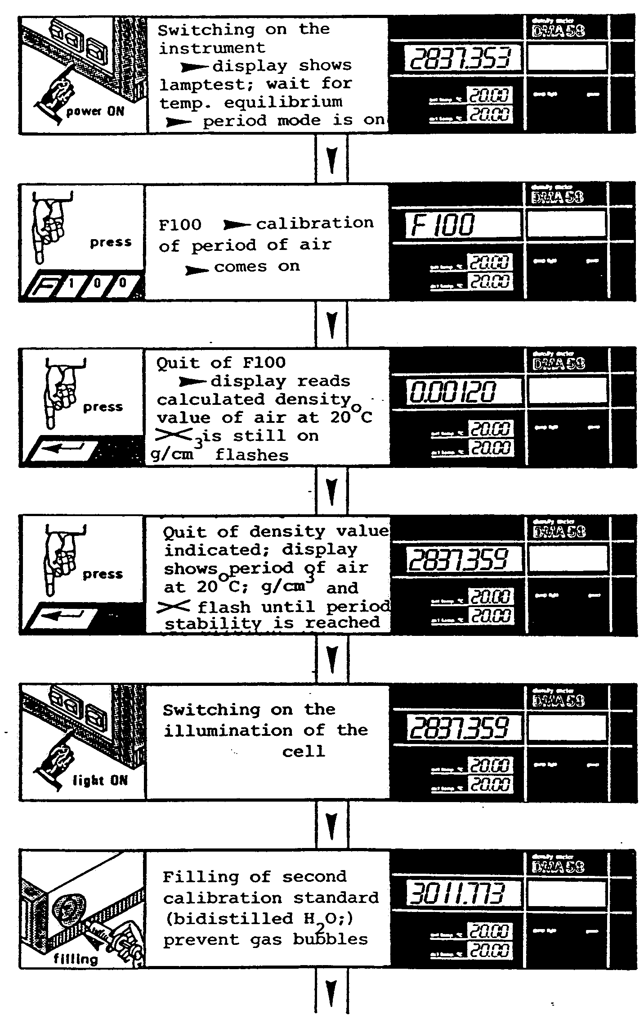 | The flashing X ceases, indicating that the machine is ready--e.g., stable measurements are being made.  After you measure the atmospheric pressure, you can enter a more accurate air density from the tables in the manual.  Yes, it matters! You will see the light raises temperature steadily.  Don't push hard! Liquid must flow through the cell easily--no bubbles. Remember, it's a glass tube you are ultimately pushing on. Be gentle. The water should still be hot/warm. It will not take very long for the instrument to return to set point temperature. Make sure tube stays full, as the water will contract a bit. No bubbles! You could leave the syringe dangling so you can push a little more water in as it cools.

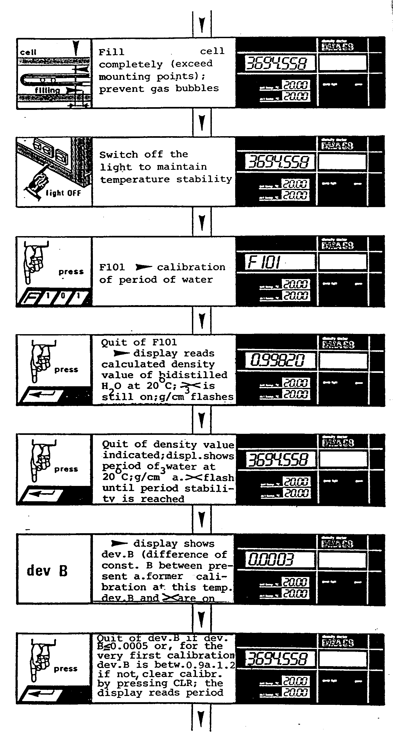 | The cell is overfilled, to ensure that the vibrating part is completely full. The ends are fixed and don't vibrate.  PLOT dev B on the nearby chart. Trends matter!  If dev B is too large, clean with isopropyl again and repeat. If that doesn't work, try other gentle solvents, always returning to isopropyl. Except for gunk, the calibration should almost never change. Sudden changes are particularly suspect.

Really, Really Short Calibration Instructions

Remember--you must often wait for temperature equilibration, no flashing X. Let's call these waits EQUIL.

- FILL OUT LOG BOOK ENTRY/CHECK NOTES FROM PRIOR USER
- PUMP IN DRY AIR, THEN SHUT OFF PUMP & LIGHT
- EQUIL
- F100
- ENTER (optional, type in real air density)
- ENTER
- WAIT FOR PERIOD STABILITY (NO FLASHING)
- LIGHT ON
- FILL CELL WITH BOILED WATER (STILL WARM/HOT) VERY SLOWLY TO PREVENT BUBBLES.
- EQUIL
- F101
- ENTER
- ENTER
- EQUIL -- DISPLAY SHOWS dev B
- IF FIRST CALIBRATION AT THIS TEMPERATURE, dev B SHOULD BE BETWEEN 0.9 AND 1.2. OTHERWISE, dev B SHOULD BE < 0.0005. IF NOT, PRESS CLR (clear wrong calibration).
- IF PREVIOUS CALIBRATION EXISTS AT THIS TEMPERATURE, PLOT dev B ON THE NEARBY GRAPH.
- IF dev B OUT OF ACCEPTABLE RANGE, LOOK FOR POSSIBLE SOURCES OF ERROR ON p. 33

Actual Measurements (pages 37 et seq. in the larger manual)

If you wish, consult the manual for instructions similar to those scanned in above for calibration. Shouldn't be necessary--by now you have the hang of it. So here's the short form.

CALIBRATE (SEE ABOVE). There is no point doing an experiment if the calibration doesn't work. There is no reason to assume calibration is still OK--it's easy to test.

First sample should be your solvent! (Measure nothing first!)

Proceed thusly from low concentrations to high

Really, Really Short Measurement Instructions

- LIGHT ON
- FILL THE CELL WITHOUT BUBBLES
- LIGHT OFF
- EQUIL
- F505
- ENTER (display shows density)
- F500
- ENTER (display shows period)
- RINSE CELL EXTENSIVELY WITH NEXT SOLUTION (if you have a lot)
- OR….RINSE EXTENSIVELY WITH SOLVENT/ETHANOL/DRY (if you must conserve solution)
- IN THE FINAL END, RINSE WITH GOBS OF SOLVENT TO REMOVE ALL TRACES OF POLYMER.
- TEST THAT DENSITY OF SOLVENT HAS NOT CHANGED (if it has, you didn't get all polymer out!)
- MEASURE THE DENSITY OF WATER AND CHECK AGAINST TABLE
- EXTENSIVELY RINSE WITH ETHANOL AND BLOW DRY.
- MAKE ANY NOTES IN LOGBOOK
- MAKE SURE YOU PLOTTED YOUR dev B VALUE
- TURN INSTRUMENT OFF.

A Learning Experiment

Objective: use the DMA 58 to measure some convenient polymer solution. "Convenient" means it dissolves fast to make concentrated solutions, such that ρ⁻¹ is interesting (i.e., curved), without getting highly viscous (so we can clean it out easily).

Plan: make solutions of a low-M poly(ethylene glycol), PEG, by weight in the range 0 - 50% and measure. This won’t be very curved, but maybe a little.

- Use vacuum oven to dry PEG-8000. The main precaution to using a vacuum oven is to make sure it is vented to the open atmosphere whenever the vacuum pump is turned off. Otherwise, it will suck the oil right out of the pump…and onto your sample.
- Weigh PEG and high-quality water in capped vials with a stirbar.
- Calibrate DMA 58 with boiled water, as above.
- Use to measure density as a function of weight percent PEG.
- Plot ρ⁻¹ vs. w.
- Fit polynomial to this, and report and .as functions of w.

Materials: about 10 capped 10-mL vials, stirring bars, PEG-8000, Nanopure water, plastic-tipped syringes for injection.

Accommodation for working in a course environment: Each person should make one solution of PEG-8000/H₂O, writing details of the sample preparation in their lab notebooks. Everyone can try their hand at calibration (easy and fast) to learn about injection. Everyone should measure the density with the same calibration in effect.

Reporting requirement for MS-II course: This will appear as an assignment.
Another Learning Experiment

Objective: demonstrate that is not a constant using simple fluids, ethanol and water.

Plan: make solutions of absolute (no denaturant) ethanol and water, which should exhibit “something cool” around 17-18% by weight.

- Calibrate DMA 58 with boiled water, as above.
- Use to measure density as a function of weight percent PEG.
- Plot ρ⁻¹ vs. w.
- Fit polynomial to this, and report and .as functions of w.

Materials: about 10 capped 10-mL vials, absolute ethanol, Nanopure water, plastic-tipped syringes for injection.

Accommodation for working in a course environment: Each person should make one solution of Ethanol/H₂O, writing details of the sample preparation in their lab notebooks. Everyone can try their hand at calibration (easy and fast) to learn about injection. Everyone should measure the density with the same calibration in effect.

Reporting requirement for MS-II course: This will appear as an assignment.
How Good Should the Experiments Be?

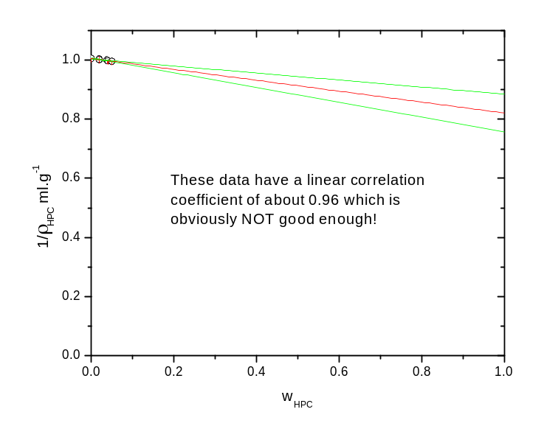

Answer: very, very good. It’s a long, long extrapolation!

Hint: you can plot these data against w_{H2O} instead. Then the plot will look like this:



